**Feb 2021**

**Fiverr Website Review**

<https://wbsrch.com/>

* The layout of the website is extremely minimalistic. I would recommend adding some more color.
* The top line/ logo on the page (highlighted in a red box in the screenshot below) seems repetitive with Web Search being stated twice, only with different spellings.
* The primary selling point for your search engine, (highlighted in green box in the screenshot below), should be in a larger font/ different color to highlight it more. If there are additional selling points, they should also be included as they would help with website visitor retention and reduce the white space.

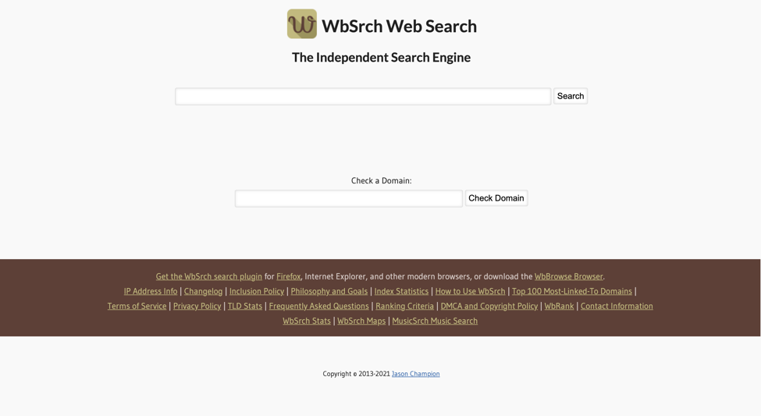

* Basic search function and domain search works well. In terms of the aesthetics of the search result, I would recommend having more space between each result. The screenshot below shows that the results are too closely spaced, making them hard to distinguish.

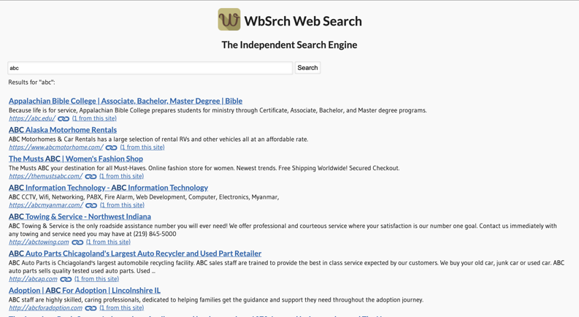

* Links at the bottom of the page work well.
* The same spacing issue is also present in the Frequently Asked Questions Page.